**Architecture and Design of the Project**

**3.1 Architecture:**

**3.2 SiteMap:**

**3.3 Design:** *(User Interface Design Templates)*

**3.4 Data Flow Diagram (DFD)**

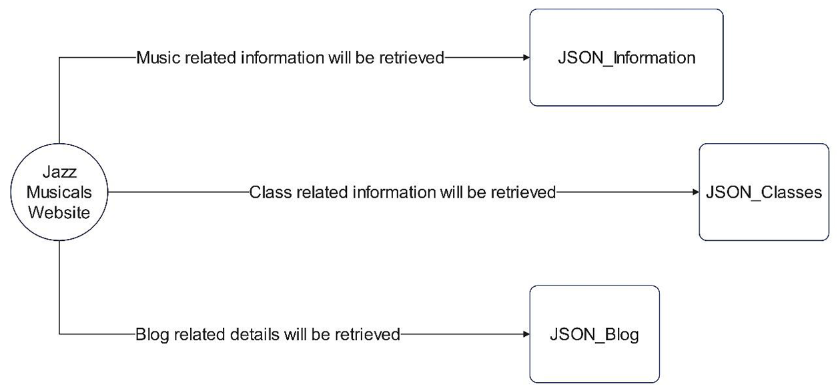

**3.5 Flowchart**

3.5.1 Home page

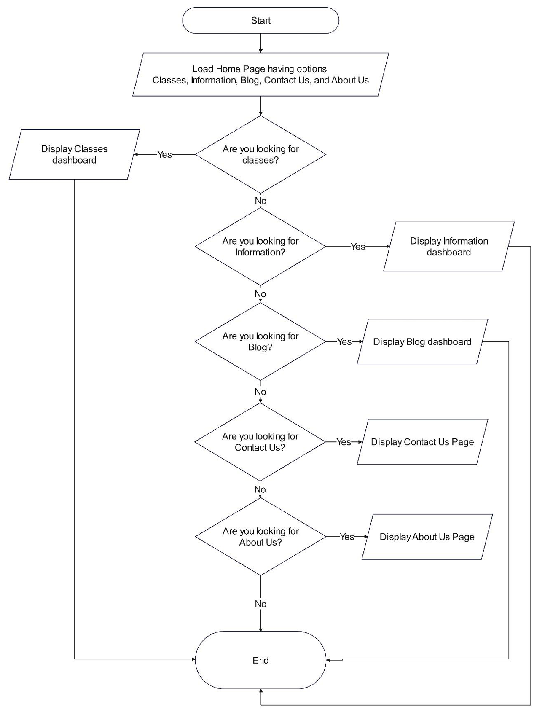

3.5.2 …

**3.6 Entity Relationship (ER) Diagram :**

* Not applicable as there are no Entities in this system